|  |  |
| --- | --- |
| Name : Bularon,Mona Lyn C. | Section : BSIT 3C |
| Assignment No : 3 | Submission Date : April 6,2024 |
| Assignment Title: Number Guessing Game | |

**Code :**

**HTML FILE**

<html lang="en">

<head>

    <meta charset="UTF-8">

    <meta name="viewport" content="width=device-width, initial-scale=1.0">

    <title>Document</title>

</head>

<link rel="stylesheet" href="index.css">

<body>

    <h1>Number Guessing Game </h1>

    <h4>Guess a number between 1-10:</h4>

    <input type="text" id="guessNumber">

    <button onclick="checkGuessNumber()">Enter</button>

    <h4 id="inputNumber"></h4>

    <script src="index.js"></script>

</body>

</html>

**JS FILE**

var randomNumber = Math.floor(Math.random() * 10) + 1;

var attempts = 0;

function checkGuessNumber() {

    var guess = document.getElementById('guessNumber').value;

    // Validate input

    if (isNaN(guess) || guess < 1 || guess > 10) {

        document.getElementById('inputNumber').innerText = "Invalid input: Please input a number between 1 and 10";

        return;

    }

  attempts++;

    if (guess == randomNumber) {

        document.getElementById('inputNumber').innerText = "Congratulations! You've guessed the correct number in " + attempts + " attempts!";

    } else if (guess < randomNumber) {

        document.getElementById('inputNumber').innerText = "Too low! Try again.";

    } else {

        document.getElementById('inputNumber').innerText = "Too high! Try again.";

    }

}

**CSS FILE**

body {

    font-family: Arial, sans-serif;

    text-align: center;

}

h1 {

    color: brown;

}

h4 {

    color: brown;

}

button {

    background-color: antiquewhite;

    color: rgb(3, 2, 2);

    text-align: center;

    display: inline-block;

    font-size: 16px;

    margin: 4px 2px;

    cursor:pointer;

    border-radius: 5px;

}

button:hover {

    background-color: #a04545;

}

input[type="text"] {

    padding:8px;

    width:200px;

    border-radius: 5px;

}

**SCREENSHOT**

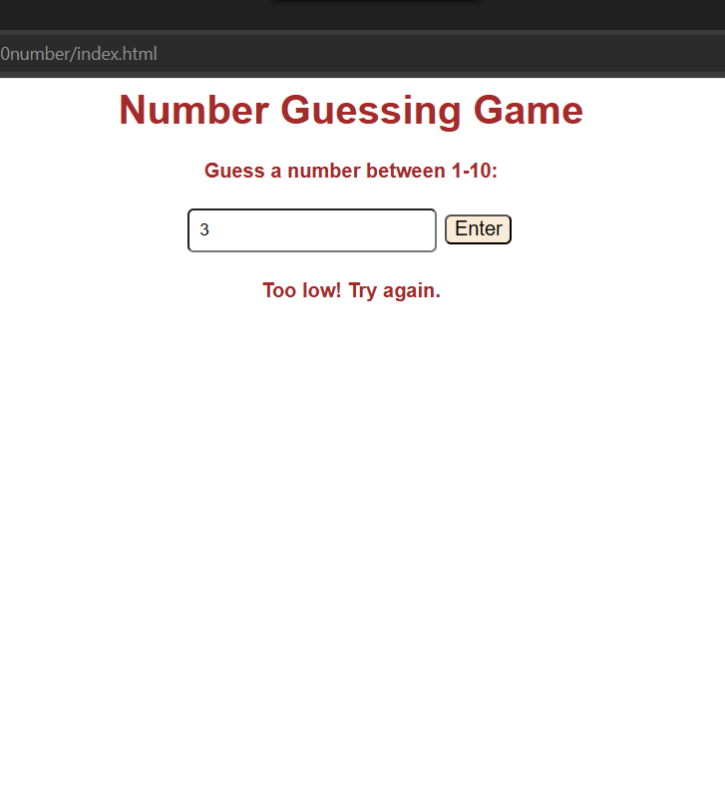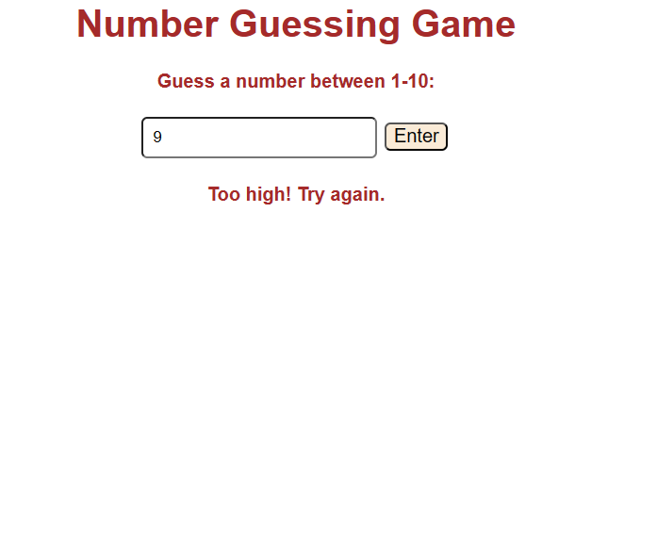

**Dictionary:**

*// List keywords, tags, or methods that are new to you and explain how they are used in the code.*

*// atleast 5 tag, methods or keyword*

**1.value** – a function that allows to get the value of the input field being input by the user.

**Syntax** :     variable name = hold an expression (string).value;

**Parameter** : string (variable)

    var guess = document.getElementById('guessNumber').value;

**Output :** // the user input being read

**2.return; -** It is used to end the execution of the program.

**Syntax:** return;

**Parameter:**

    if (isNaN(guess) || guess < 1 || guess > 10) {

        document.getElementById('inputNumber').innerText = "Invalid input: Please input a number between 1 and 10";

**return;**

    }

**Output:** // end of the execution

**3.innerText-** this function allows to get or set the specific text content of an html element.

**Syntax :** expression(variable name).innerText = (string)

**Parameter:** document.getElementById('inputNumber').innerText = (statement,variable)

document.getElementById('inputNumber').innerText = "Invalid input: Please input a number between 1 and 10";

**Output: *//*** *user input a random number*

Invalid input: Please input a number between 1 and 10.

**4.++-** It is called an increment operator, it used commonly to increase the value of a variable by 1.

**Syntax :** variablename++

**Parameter:**

  attempts++;

**Output:** // value add 1

**5.Input type**- The `input type` in HTML is an attribute used to specify the type of input field you want to create on your web page.

**Syntax:** <input type=(string)>

**Parameter**:input type = ( variable name)

<input type="text" id="guessNumber">

**Output**